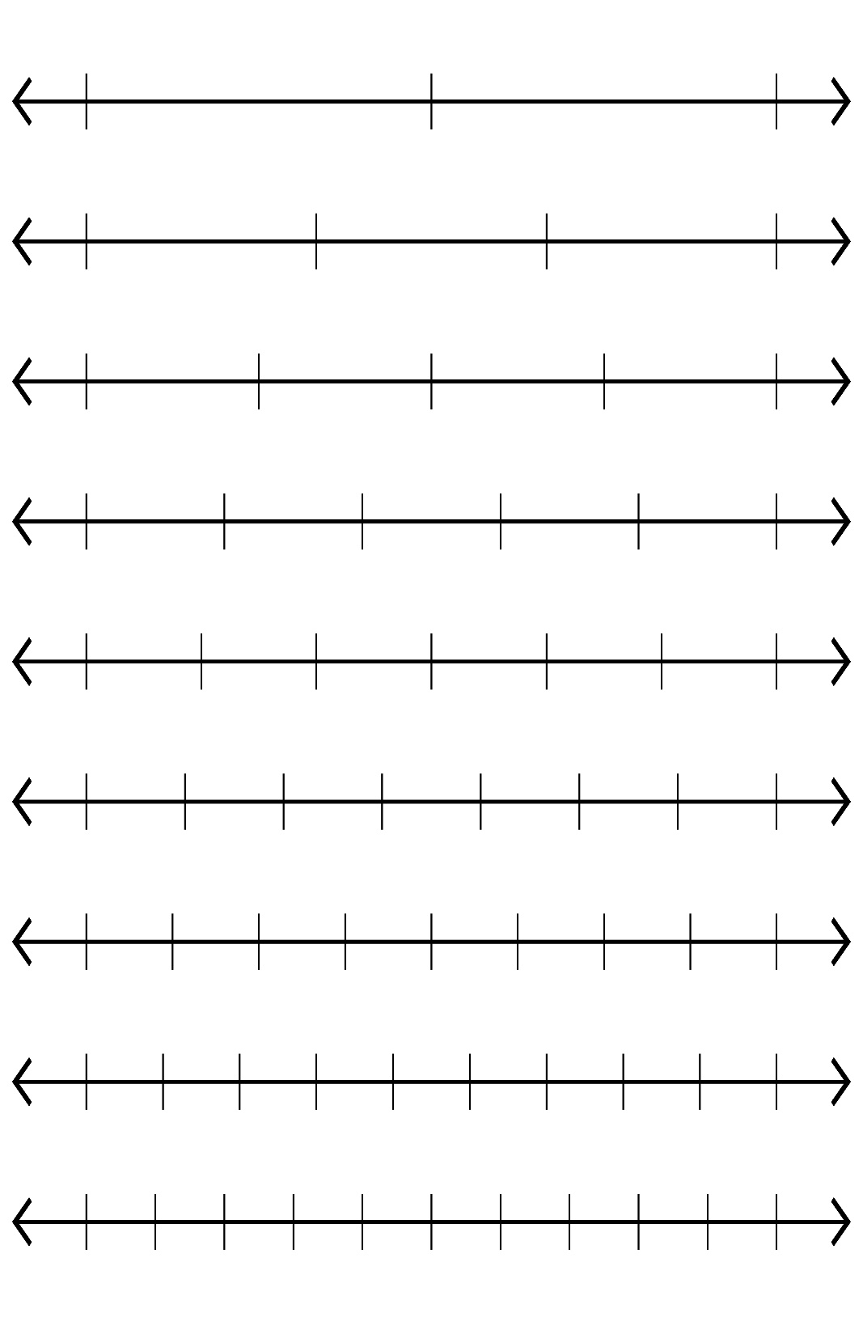Comparing Fractions using Number lines

**Task 4:** Put the following fractions on the number lines below:

$\frac{1}{4}$ $\frac{3}{6}$ $\frac{5}{10}$

**Task 3**: Can you see any patterns in the number lines above?

_______________________________________________________________________________________________________________________________________________________________________________________________________________________

**Task 2**: Are there any equivalent fractions? Write them below using the symbol =

**Task 1:** Complete the number lines below:

**Task 5:** Compare the fractions using the symbols for “equal to,” “greater than” and “less than”