Class 1. FOURTH PROPERTY OF LIGHT
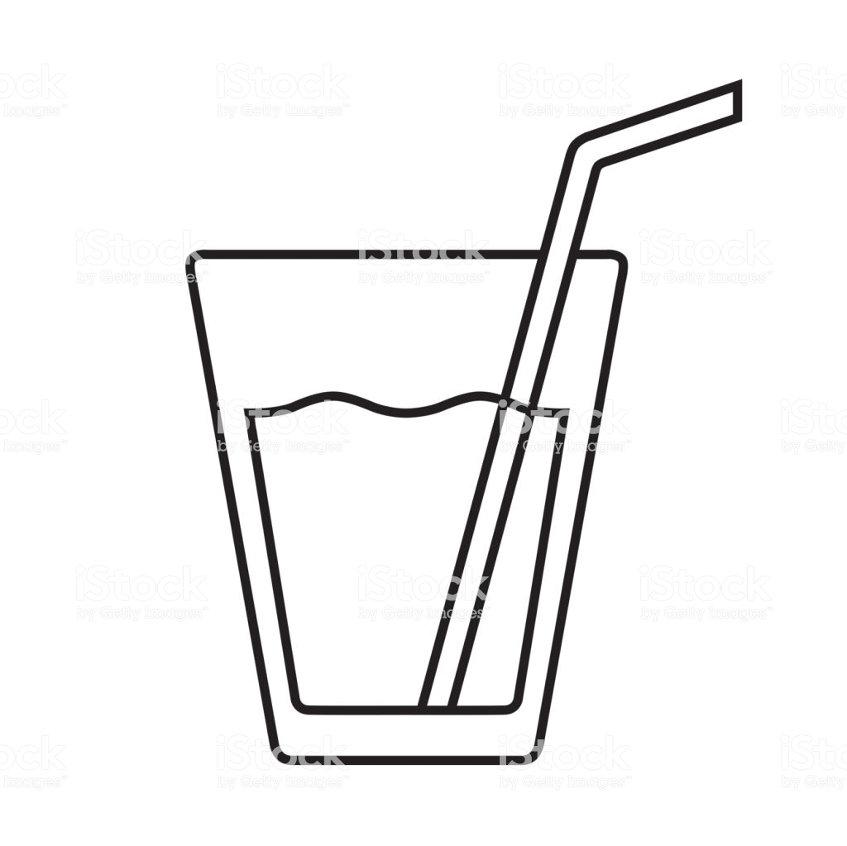

Hello Boys:
During this class you will learn the fourth property of light.
Is this image showing what happens in real life?
LIGHT CAN BE REFRACTED.

You need:
No, we see the straw bent because of the refraction of light .
Your notebook, your pencil case, a glue stick, a good connection to the internet to watch a video, a clear glass or cup, and a color pencil or a straw.
If you print this worksheet paste it in your notebook, if not, just write the answers in your notebook. Write the title and the date.
Remember to organize your materials and space to work in a more efficient way!
LET´S START!
- Experiment

Glass without water | Glass filled with water
Instructions:  - Take a pencil or straw and place it vertically in a clear glass without water. Do not hold it.  - Make a drawing of what you observe when you look at the cup from the side.  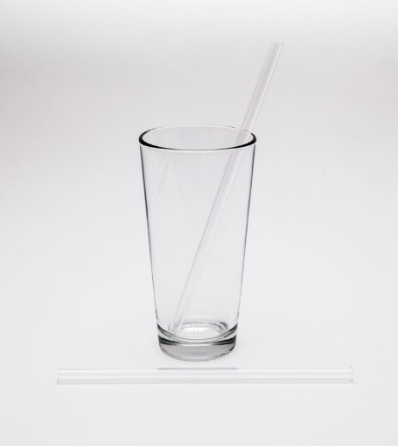 | Instructions:  - Fill the clear glass or cup with 2/3 of water.  - Take a pencil or straw and place it vertically in the water but do not hold it.  - Make a drawing of what you observe when you look at the cup from the side.  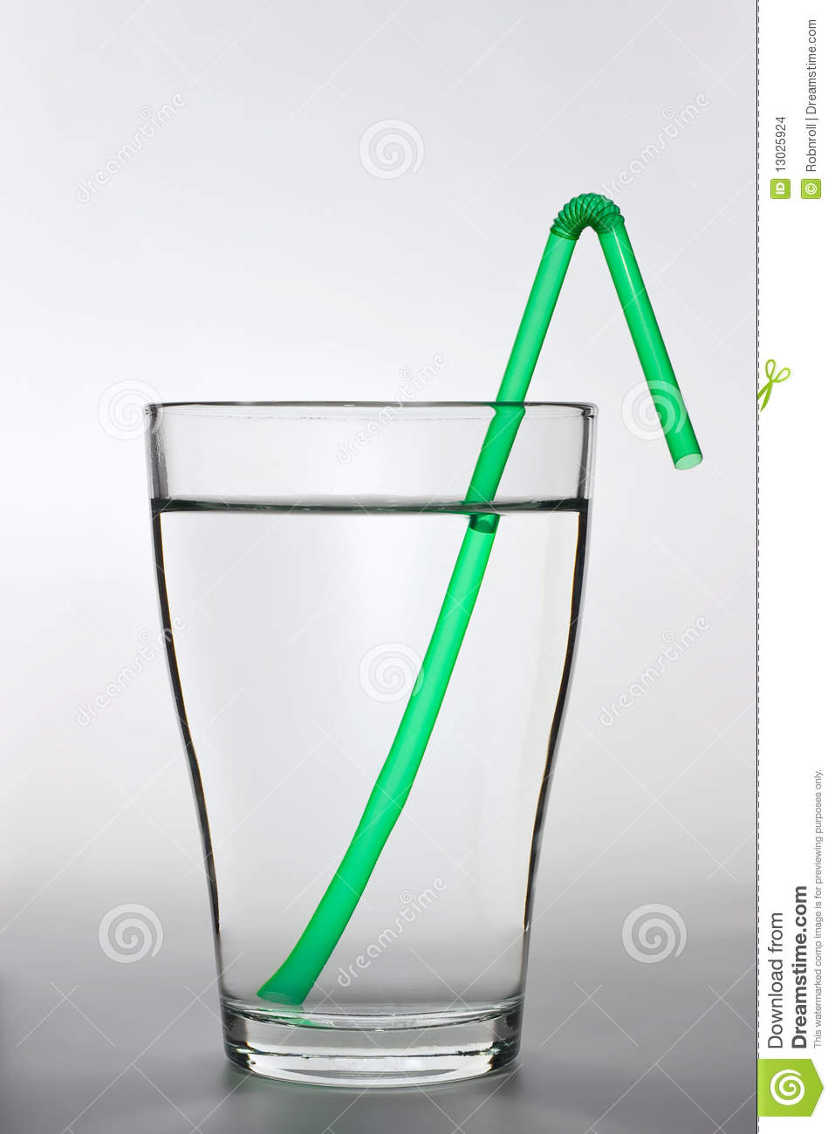

- Watch the video: Refraction of Light - Why does a pencil look bent in water?
https://www.youtube.com/watch?v=SeaWCamCHWQ

3. Answer the following questions (IM1 and IM2)
Why does the pencil appear bent in water?
The pencil appears bent in water because of the refraction of light.
Define refraction of light
Refraction of light is the change in direction of light when it passes from one medium to another obliquely. (at an angle, diagonally like this /)
What were the two mediums in the experiment?
The two mediums in the experiment are air and water.
The term refraction means to bend. Why do light rays bend?
The light rays bent because they change their direction when the light pass from one medium to another.
Is the straw or pencil bent or is that an illusion created by light refraction?
It is an illusion created by light refraction.

