My Dream Bedroom Project
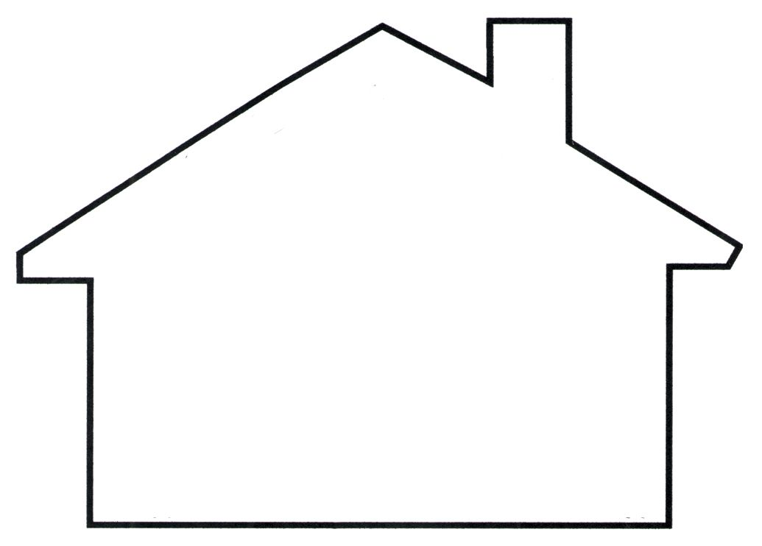

IM1: _____
CT1: _____
C2: _____
M1: _____
M2: _____

Created by ___________________
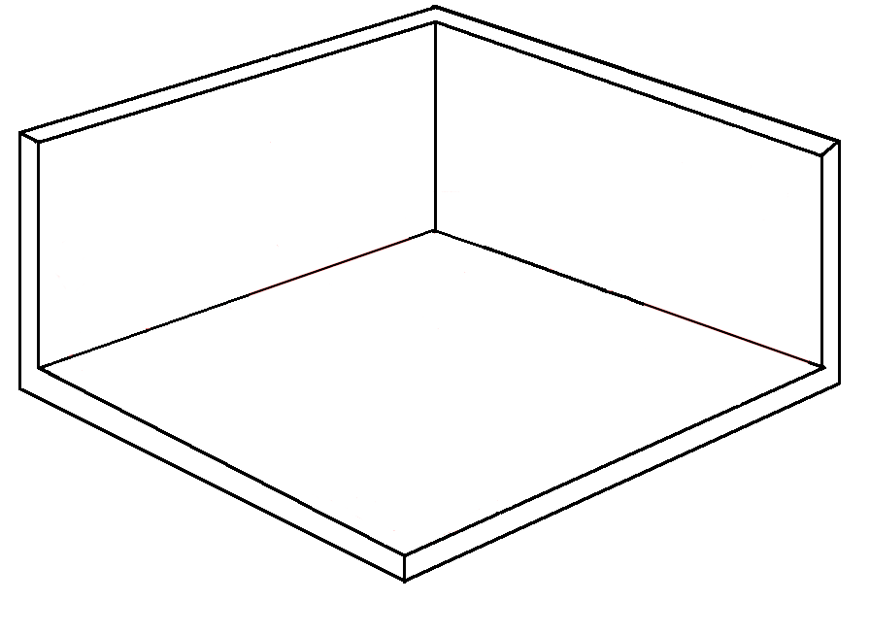
Remember: Explain what the objects are and what you will use them for. Your dream bedroom must include items that are the following shape: 1 rectangle and 1 square
The area of my dream bedroom is:
My Dream Bedroom
4 meters
The perimeter of my dream bedroom is:
6 meters
The Objects in my Bedroom

This object is ____________________ | Choose the best units of measurement for your object. You can use mm, cm, m, km  The length of this object is 23 ____.  The width of this object is 18 ____. | Find the area of the object:  The area of this object is _________.
This object is ____________________ | Choose the best units of measurement for your object. You can use mm, cm, m, km  All the sides of this object are equal. The length of one side is 13.5 _____. | Find the perimeter of the object:  The perimeter of this object is_______.

Remember: Explain what the objects are and what you will use them for. Your dream playroom must include items that are the following shape: 1 rectangle and 1 square

My Dream Playroom

The perimeter of my playroom is 26 meters. The width of one side of the playroom is 5 metres. What is the length of one side? (Show your working out)

Perimeter: 26metres Width: 5metres Length: _____ metres
What is the area of your dream playroom? (Show your working out)

The area of the playroom is ________.
The Objects in my Playroom

This object is ____________________ | Choose the best units of measurement for your object. You can use mm, cm, m, km  All the sides of this object are equal.  The length of one side is 8 ____. | Find the area of the object:  The area of this object is _________.
This object is ____________________ | Choose the best units of measurement for your object. You can use mm, cm, m, km  The area of the object is 207___ ²  The width of this object is 9 ___. | Find the width of the object:  The width of this object is_______.

Look at the rooms you have created. Choose a room or an object, and using the measurements create a word problem. You need to create one word problem about area or perimeter, and another one to find the missing length of a side. Check your word problem using the checklist when you have finished.
Creating a Word Problem

Task | Write the word problem | Check
Create a word problem to find the Perimeter or Area.  Use an object or a room in your dream rooms to do this. | _________________________________________________  _________________________________________________  _________________________________________________  _________________________________________________ | - Does it have units of measurement?  - Does it have a question mark?  - Is it possible to solve (does it make sense?)  - Have you checked your spelling of key words?
Create a word problem to find the missing length of a shape  Use an object or a room in your dream rooms to do this. | _________________________________________________  _________________________________________________  _________________________________________________  _________________________________________________ | - Does it have units of measurement?  - Does it have a question mark?  - Is it possible to solve (does it make sense?)  - Have you checked your spelling of key words?

Goals to Improve | How will you improve? Tick or underline 1 or 2 strategies for each box. | Friday 22nd May
Organisation and Productivity. | - I will make sure I have all my materials ready before I start.  - I will work in a quiet place without distractions.  - I will take regular breaks.  - I will use the PowerPoint guide to help me. | 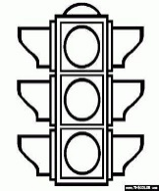
Understanding: Area and Perimeter. | - I will review the formulas for area and perimeter before I begin  - I will watch Math Antics or other YouTube videos to review concepts.  - I will use Brain Pop to clarify my doubts  - I will review PowerPoints from past weeks to clarify my doubts.
Checking my Project. | - I will check I have included my units of measurements.  - I will check all operations with the opposite operation.  - I will re-read my work after I finish it.  - I will re-read instructions and underline the key words. | 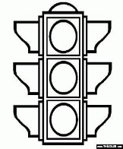
For this project you will be using lots of different skills we have been developing in Math. It is really important to have a plan to help us achieve our goals for our Dream House Project. Choose 1 or 2 of the strategies for each goal below.
Metacognition: My Dream Room Project
I have finished my project. I was good at ____________________________________________________________.
Something I need to improve further is ________________________________________________________________.
I will improve this by _________________________________________________________________________________
_____________________________________________________________________________________________________.

