Name: _____________________________ Date: ________________
M₁ | M₂

Metacognition Trimester 3: English

Complete the chart below with the strategies you will use to complete your project. You can either highlight the strategy or color the circle next to it. You should only choose 1 for each category.
RED: I still need to work on this a lot.
YELLOW: I have improved but I still need to work on this.
GREEN: I can do this perfectly.

Things to Improve | How will you improve? | Self-Evaluation
Content and Understanding | - I will look for more videos that help me improve my writing.  - I will read more stories to find how they display the different parts of the plot.  - I will read the instructions as many times as I need to complete it correctly. | 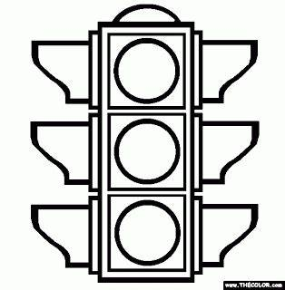
Behaviour and Attitude towards working at home | - I will keep a positive attitude while doing my work (I won’t complain).  - I won’t have distractions such as music, TV or video games while I work.  - I will organize my space and focus on my work.
Time Management | - I will follow the daily schedule to complete my story.  - I will set a goal and work on it until I finish.  - I will focus on one task and part at a time.
Check, Review | - I will check my work every day.  - I will check and correct my spelling.  - I will re-read my story to make sure others will understand it.

Now reflect about your process:

I was great at
I still have to work on
To improve, next time I will
To achieve all my goals I will

