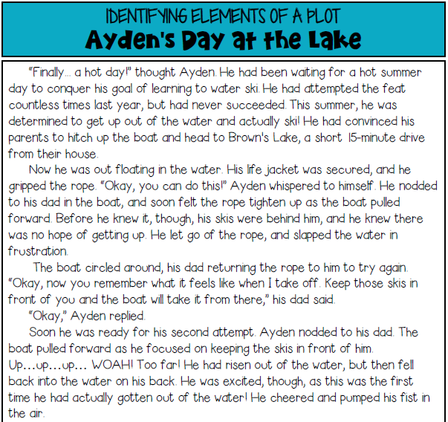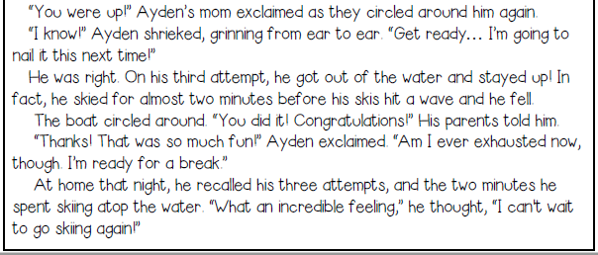
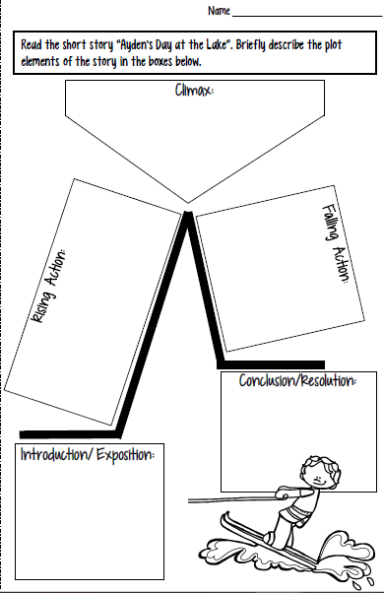

At home that night, Ayden recalls his achievement; he can’t wait to go water skiing again. | On Ayden’s first attempt, he is unsuccessful. He never even gets out of the water
Family goes to the lake; reader learns Ayden has a goal of learning to water ski. | On this third attempt, Ayden succeeds, skiing atop the water for nearly two minutes.
Ayden’s second attempt is partially successful; he gets up on his skis for a moment but falls back into the water. However, he is excited and encouraged because of his progress.

