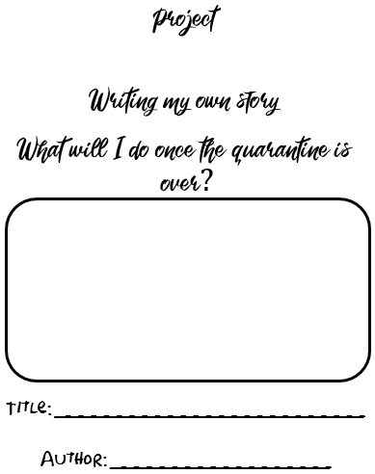

|  |  |
| --- | --- |
| IM2 |  |
| CT1 |  |
| CT2 |  |
| C1 |  |
| C2 |  |

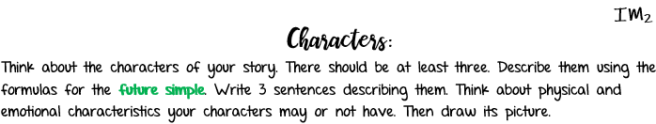



|  |
| --- |
|  |
|  |
|  |

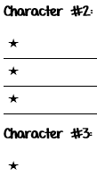

|  |
| --- |
|  |
|  |
|  |



|  |
| --- |
|  |
|  |
|  |

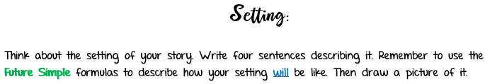

|  |
| --- |
| * **It will be** |
| * **It will have** |
|  |
|  |





  
  
  
  
  
  
  
  



  
  
  
  
  
  
  
  
  
  



  
  
  
  
  
  



  
  
  
  
  
  
  
  



  
  
  
  
  
  
  
  



