Name: ____________________ Date: _____________________
Finding the Area of Quadrilaterals
Remember: A = W x L
Find the area of the shapes below:
1.  12cm  7cm  The area is ___________. | 2.  8 cm  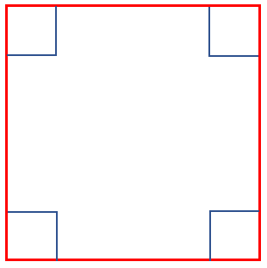  The area is ___________.
3.  12m  The area is ___________. | 4.  2m  18m  The area is ___________.
Find the length of the missing sides:
5.  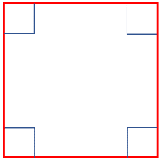  A = 25m²  ?  The length of one side is ____________. | 6.  ?  8m  A = 48m²  The length of one side is ____________.
Finished? Go back and check you have included the units of measurement and the squared symbol. Without these, your answer is incorrect! (cm², m²)

