Name: ____________________ Date: _____________________
Answers:Finding the Area of Quadrilaterals
Remember: A = W x L
Find the area of the shapes below:
1.  12cm  7cm  The area is 84cm² | 2.  8 cm  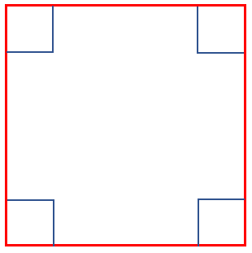  The area is 64cm²
3.  12m  The area is 144m² | 4.  2m  18m  The area is 36m²
Find the length of the missing sides:
5.  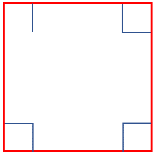  A = 25m²  ?  The length of one side is 5m | 6.  ?  8m  A = 48m²  The length of one side is 6m.

