Name: ____________________ Date: _____________________
Finding the Perimeter.
Remember: P= L + L + W + W
Find the perimeter of the shapes below:
1.  10.5cm  5.4cm  The perimeter is 31.8 cm. | 2.  15 cm  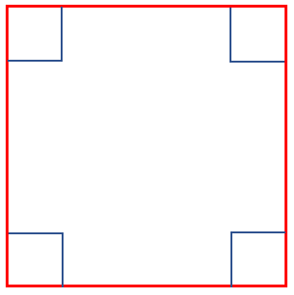  The perimeter is 60 cm.
3.  11.2m  The perimeter is 44.8 m. | 4.  1m  1.7m  The perimeter is 5.4m.

Find the length of the missing sides:
5.  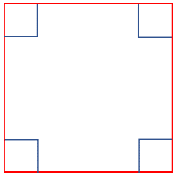  P = 36m  ?  The length of one side is 9 m. | 6.  ?  8.5m  P = 25m  The length of the missing side is 4 m.

