Name: ___________________ M1: ___ M2: ___
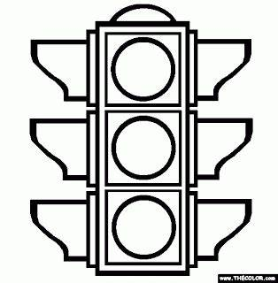
Metacognition Trimester 3: Math
You have been working from home for the last 2 weeks instead of in the classroom. You are going to use this chart to help you with strategies to stay focused and motivated whilst working from home. To complete the first half, look at the PowerPoint your teacher has sent you. She will tell you when to complete the other sections.

RED: I still need to work on this a lot.
YELLOW: I have improved but I still need to work on this.
GREEN: I can do this perfectly.
Things to improve | How will you improve? Write 1 or 2 strategies | Week 3 | Week 4 | Week 5
Attitude – staying focused, working independently | _______________________________  _______________________________  _______________________________
Understanding – clarifying doubt, checking work | _______________________________  _______________________________  _______________________________
Time Management – am I using my time wisely? | _______________________________  _______________________________  _______________________________

In week 5 reflect on your progress and answer the questions below:
I was great at ____________________________________________________________________.
I still have to work on ______________________________________________________________.
I will do this by ___________________________________________________________.

