Name: ___________________ M1: ___ M2: ___
Metacognition Trimester 3: English
Complete the chart below with a strategy to help you improve your understanding of content, behaviour and attitude, participation, and checking your work. You will self-evaluate to see if you are achieving your goal every three weeks when your teacher tells you to using the traffic light system.

Things to Improve | How will you improve? | Week 1-3 | Week 4-5
Content and Understanding | ______________________  ______________________  ______________________ | 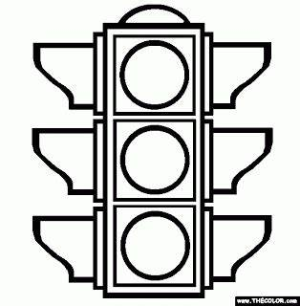
Behaviour and Attitude towards working at home | ______________________  ______________________  ______________________
Time Management | ______________________  ______________________  ______________________
Check, Review | ______________________  ______________________  ______________________
In week 3 reflect on your progress and answer the questions below:
RED: I still need to work on this a lot.
YELLOW: I have improved but I still need to work on this.
GREEN: I can do this perfectly.
I was great at _______________________________________________.
I still have to work on _________________________________________.
I will do this by _________________________________________
___________________________________________________ .
In week 5 reflect on your progress and answer the questions below:
Did you achieve your goals? Why/why not? Be honest when answering.
_____________________________________________________________________________________________________________________________________________

