Name:____________________________________________________ Date: ___________________________
Paragraph Homework

- Read the following paragraph. Circle each part and label it. Follow the example.

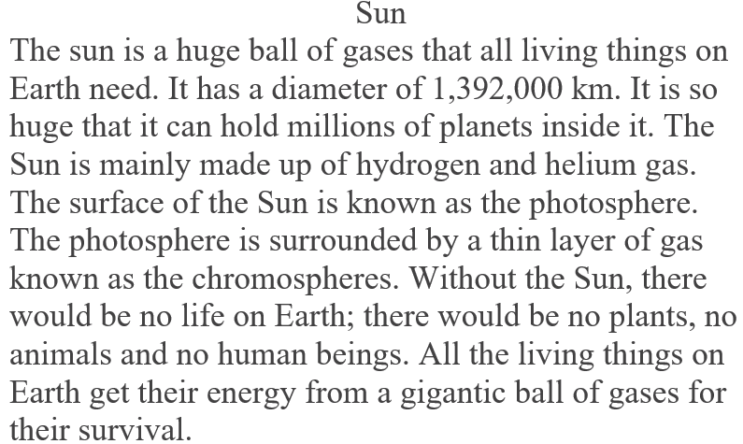
Supporting Detail

- Read each sentence. Then, order them and re-write a paragraph that makes sense. There is a topic sentence, three supporting details and a closing sentence.
Then, they place one snowball on top of another.
Next, they add rocks for eyes and a carrot nose.
It is fun to build a snowman!
I have fun with my friends in school.
Ben and Alex want to build a snowman.
First, they roll three big snowballs.

- Organize your ideas to write a paragraph about the importance of having a good behavior in class.
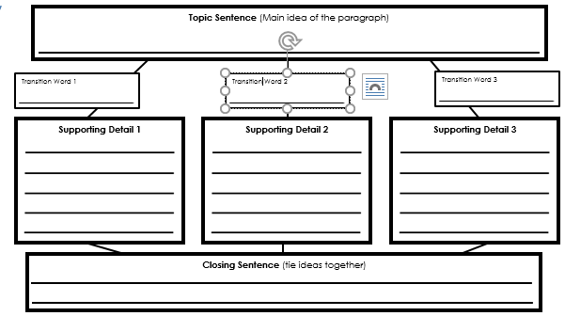

- Write your paragraph about the importance of having a good behavior in class.

- Check that every sentence starts with a capital letter and finishes with a punctuation mark.

