Class 1. FIRST PROPERY OF LIGHT
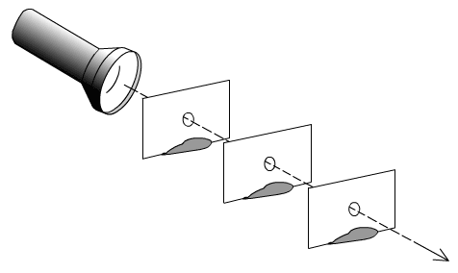
Hello Boys:
During this class you will learn the first property of light. LIGHT TRAVELS IN STRAIGHT LINES.
You need:
Your notebook, your pencil case, a glue stick, and a good connection to the internet to watch a video.
If you print this worksheet paste it in your notebook, if not just write the correct answers in your notebook.
Remember to organize your materials and space to work in a more efficient way!
LET´S START!
- Watch the video: Light travels in a straight line. https://www.youtube.com/watch?v=7ooBbUbmbJg (2:02 minutes)

- Answer the following questions (IM1 and IM2)
Why can light be seen through all the index cards?
- Because the index cards holes are lined up.
- Because the girl has a powerful torch.
- Because light travels in a straight line.
- Because the index cards are transparent.
- A and C
- B and D
Why can´t light be seen through all the index cards?
- Because the index cards are opaque objects.
- Because the index cards´ holes are not lined up.
- Because light travels in a straight line and is stopped by opaque objects.
- All of the above.

What does the experiment prove about the path light travels?
- Light travels in a straight line.
- If light finds an obstacle it will curve and go around it.
- Opaque objects cannot stop light.
- The index cards´ holes need to be lined up.
What would happen if the holes were smaller? (C1)
a. Light would continue to travel in a straight line but in a thicker path.
b. You would need a bigger torch.
c. Light would continue to travel in a straight line but in a thinner path.

Explain in one sentence what did you learn through this activity.

Light travels in straight lines.

