Names: _____________________________________ Date: ____________________________

Reading Comprehension Stations
Geronimo Stilton Rumble in the Jungle

Station 1:

Match each of the following chapters to its main idea. Write the letter corresponding to the main idea in the box right next to the title:

Destination: Adventure!

I Don’t Understand Anything!

Carnival in Rio!

What Beautiful Waterfalls!

What a Good Luck!

Station 2:

Action | Was it a good action or not? | Why was it or wasn’t it a good action?
 | It was a good action.
 | It wasn’t a good action.

Station 3:

Problem:

Alternative solution:

Station 4:

Describe a moment or an event in your life or in the life of someone you know, when you have felt in a similar way. Plan and write a 5 sentence paragraph.

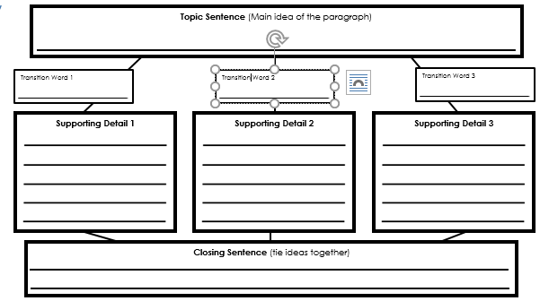

bC
Wild Willie told Geronimo many facts about Brazil and Maya tried to teach him Portuguese, but Geronimo fell asleep.

bA
Geronimo lands in Brazil and starts looking for Wild Willie and Maya.

Geronimo has to work in a hotel and dance in the carnival to pay for a night in a hotel, after losing his wallet.
bE

bD
Geronimo went to Foz do Iguaçu and he tumbled into the water.

Geronimo went to Cuiabá and met Thiago and Ana. He arrived to the fazenda and he started to learn Portuguese.
bB

Station 2
Read the chapter What Good Luck! and find two actions (1 good action and 1 that isn’t).

Station 3
Read the chapter Carnival in Rio! Find a problem and propose an alternative solution for that problem.

Station 4:
Since Geronimo woke up in the plane, he felt lost. Have you ever felt lost? If you haven’t, have someone you know felt lost?

Station 1 Answers:
C
A
E
D
B
Station 1 Answers:
C
A
E
D
B
Station 1 Answers:
C
A
E
D
B

