Dear Parent/Guardian~
I hope this resource will be helpful in keeping your kiddos from jumping on the couch or staring endlessly at screens all day, during this unscheduled time away from school.

Most of the activities they should be able to do on their own, other than a few that can be enjoyed with another household member. They should all be easy for the kids to do safely. I tried to limit most of them to inside, in the event you needed to work from home, or did not have a safe outside moving space available. Feel free to add on your own healthy activities if you think of some or have the resources to allow them.

Please know that this challenge is entirely optional, and feel free to encourage your kiddo to participate to the extent that it works for your household.! You can use the star chart to keep track and motivate your child to complete as many healthy activities as possible. Another option for fun is the Move It or Lose It game attached too!

You may also want to consider using GONoodle, even if doing the challenge does not work for you. I was able to access quite a few fun, movement based videos, by searching on Youtube for the GoNoodle ‘station’. There is a wide variety to choose from, from fast paced dances to slow stress managing.

An additional resource that may be an enjoyable option is a site called Fluency and Fitness. During this time, they are offering a 21 day membership free of charge for families to use. They focus more on reading and math~ but routinely mix in a burst of a fitness activity in between, so it may be wonderful from both a learning, and movement standpoint. This link will help you to find it easily
https://fluencyandfitness.com/register/school-closures/

Have fun and looking forward to seeing your kiddos again soon!
Elena, Andrea and Alejandra

Staying Home Days Healthy Challenge!
1.  Balloon Bang  With a partner, or by yourself,try to keep a balloon in the air as long as you can | 2.  Quarter Says  A quarter is 25 cents!  Do 25 of each:  -Jumps  -Heel Raises  -Arm Circles | 3.  Silly Sweaty  Move around safely however you want until you start to get sweaty and your heart is beating fast! | 4.  Line Jumps  Use socks to make a line on the floor. Jump back and forth as fast as you can for 30 seconds (be sure to put the socks away) | 5.  Dance Dance  Turn on your favorite song, or even just the radio. Dance however you want for the entire song! | 6.  Bicycles  Lie on your back and move your legs like you’re riding a bike to strengthen your stomach muscles
7.  GONoodle  Ask someone to help turn on a GONoodle video (or two!!) and have fun moving along | 8.  Crazy 8’s  -8 jumping jacks  -8 silly shakes  -8 seconds of dead bug  -8 cross crawls  -8 star jumps | 9.  Cobra Push  Lie on your tummy and push your shirt off the ground for 10 seconds. Do it 10 times. | 10.  Yoga Time  Pick a yoga card and do each of the poses on it for 20 seconds each | 11.  Star Jumps  Jump up with your arms and legs spread out like a star. Do 10, then rest and do 10 more! | 12.  Play Catch  Grab any ball and play catch with a family member. Be sure to keep your eye on the ball!
13.  Bear Walk  With your bottom in the air, step forward with your right hand and left foot. Then move your left hand and right foot forward! | 14.  Boat Pose  Hold boat pose for 15 seconds.  Do it three times!  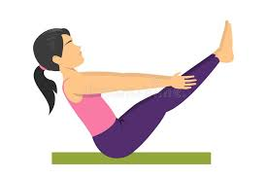 | 15.  I Spy Walk  Go for a walk with a family member while you play ‘I spy’.  Check with a grownup to decide if you should walk inside or out! | 16.  Target Toss  Find a pair of socks to make a ball. Use an underhand throw to get them into an empty box or basket. Back up a step when you make it in! | 17.  PE Pretend  Pretend to:  - sit in a chair for 10 seconds  -roll a bowling ball at 10 pins  -ride a horse 10 steps forward  -shoot 10 basketballs | 18.  Jumping Beans  Be creative and see how many different ways you can jump rope. Use a pretend rope if you need to!
19.  TV TimeOut  During the commercial break take a walk. See how many rooms you can walk through before the show starts again! | 20.  Balloon Dance  Stand back to back with a partner. Turn on some music and dance without dropping the balloon | 21.  Wacky Words  Write down all the active words you can think of. Then, safely try to act them all out! | 22.  MiniMotor Move  Put together a big puzzle or write the whole alphabet. When you finish, jump as high as you can 10 times to celebrate | 23.  Balance Pose  Balance on your right hand and left knee for 30 seconds, then switch sides and do it again  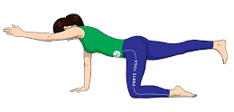 | 24.  Take a Walk  Go for a walk with the grownup who takes care of you. Look for something that starts with each letter of the alphabet while you walk
25.  Radio Run  Get help to play your favorite song and run in place until the song is over | 26.  Get Out!  Take your grownups outside and show them your best moves for at least 15 minutes | 27.  Clap and Catch  Throw a soft object in the air. See how many times you can clap before you catch it | 28.  Show Show Off  Do as many jumping jacks as you can during the commercial of your favorite show | 29.  Music Mover  Play your favorite music for 10 minutes and try to dance the whole time | 30.  Countdown  -10 frog jumps  -9 supermans  -8 cross crawls  -7 arm circles  -6 jumping jacks  -Repeat with 5-1

Staying Home Days Healthy Challenge!

Name:____________________________________

Each time you do an activity, write down the number inside a star! Try to do at least 3 each day~ MOST days!!

Day 1 | Day 2
Day 3 | Day 4
Day 5 | Day 6
Day 7 | Day 8
Day 9 | Day 10
Day 11 | Day 12
Day 13 | Day 14

Total staying home activities ____________________ Grownup Initials____________

FINISH!! |  | Long Jump! Jump as far forward as you can, then move one extra space. |  |  |  | Move It  or  Lose It!
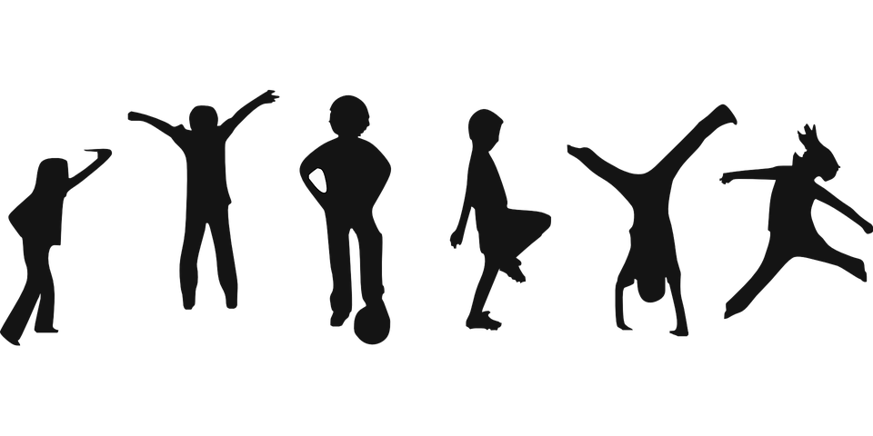 |  |  |  |  | Oh No! You’re out of breath, lose a turn.
Dead Bug  8 seconds |  | Jump side to side as you count to 30 |  |  | Touch your Head, Shoulder, Knees and Toes, 9 times | Rules to Play!  1. Roll a dice or spin a spinner  2. Move that number of spaces  3. Follow the written directions if you land on a spot  4. Celebrate when you reach the finish line!
 |  | Do 10 cross crawls on each side
Your laces are untied! Go back to start. |  |  |  |  | Superman  8 seconds
Crab walk while you sing the whole alphabet song. |  | Count to 30  while you run in place |  |  | You had a great warmup, move ahead 3 spaces.
 |  | Oh No! You stopped to watch TV. Go Back |  |  | Warm up  10  Jumping Jacks
You’re full of energy! Do 10 star jumps then take another turn! |  | Balance on one leg for 15 seconds, switch legs and repeat. |  |  |  | START!!

