Name: _______________________Date: ______________Grade: ________

DEFINING CONCEPTS: STRUCTURES AND FUNCTIONS

Discuss with your class and complete the following chart.
Structure | Function

Read the following definitions of daily live objects and underline in blue the structure and in red the function.
Fork  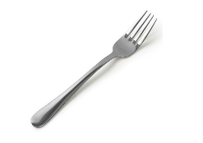 | A small usually metal implement consisting of two, three, or four long thin prongs on the end of a handle, used for lifting food to the mouth or turning it in cooking, etc.
Hammer  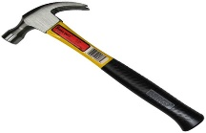 | A tool that consists of a heavy piece of metal at the end of a handle. It is used, for example, to hit nails into a piece of wood or a wall, or to break things into pieces.
Give your own example

Defining Vascular Plants
Watch the video Plant Parts and Their Functions and complete the following activities.

- Fill the blanks.
The Parts that help plants get water, make food and grow are: ____________, _____________, and _____________________. The parts that help the plants to grow new plants are: _______________, _______________, and ___________________.

- Vascular plants are made up of different parts. Match the parts to the picture below.

Complete the table below with the structures and functions of vascular Plants
Part | Structure- describe | Function/ Job
The roots
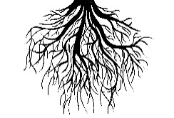
The stems
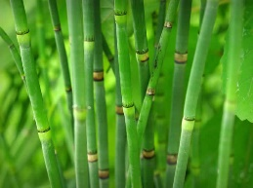
The leaves
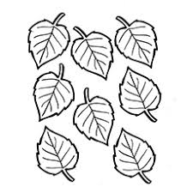
The flowers
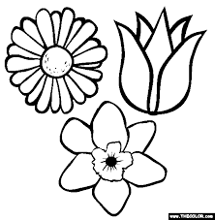
The seeds/ fruit
